An Essay on Swedish Economic History

Niall Ferguson has proposed six major concepts that helped the western countries including Sweden gain dominance over the rest since beginning of 15th century. These concepts can be identified as competition, science, the rule of law, consumerism, modern medicine, and the work ethic.

We can understand these concepts through several examples across the 4 major ears in the history, namely: The Scientific Revolution, Globalization, The Agrarian Revolution &The Industrial Revolution, leading to structural transformation within cultural and economy of the western countries.

Screening through the history, we can find EU went through a phase of numerous wars (eg. Between 1500-1799 Spain was in war 81% of the time followed by England 51% of the time) and intense competition leading to significant technological and scientific advancement in warfare and military as observed during the scientific revolution. This intern also helped different European countries colonize and gain dominance. However, one can also argue the role of competition for resources among the European countries leading to establishment of trade routes and globalization as early as 15th century. During years that flowed, fueled by continuously growing consumerism and mercantilism within European countries and significant advancements within warfare and military, the global trade expanded at an enormous pace through dominance and colonialization. Raw materials such as cotton, coffee and tea, precious metals such as gold and silver as well as spices were traded from different parts of the world and processed within the country to generate finished goods, thanks to the technological innovations through advancement within science, that were in-turn used to buy more of the raw materials. The global trade expanded to include slaves bought using the finished goods creating a cycle of continuous growth especially for the western countries producing finished goods that carry a higher value. E.g. Cotton fabrics produced in England were sold within Gold Coast to buy slaves, who were then transported to America to produce cotton that would eventually make it way into England. This is just one of the several such trade triangles among the western countries and the colonies with slave trade peaking during 18th and 19th century.

Like most European countries who colonized parts in Asia, Africa and America, Sweden had also established global trade but was also able to exploit land in the north dominated by Sami population. Thanks to established of rule of law and property rights, Swedish state was able to colonies the areas rich in iron deposits from indigenous Sami population. With inspiration from Martin Luther, Gustav Vasa was able to put church under the crown and establish ownership of Norrland or wasteland with the crown, curtailing the rights of Sami population to own the land. The colonization of Norrland was essentially possible not only because of maturing tax and governing laws but also because of growing markets and financial institutions that matured over time.

While the global trade helped western countries including Sweden grow exponentially, it would not have been possible without structural transformation within the respective countries as observed by privileges and exception from custom duties that some of the trading firms enjoy. E.g. Swedish East India Company within Sweden. One can think about such privileges only in an economy with well-established cities, markets, and institutions, one where commerce, taxation and financial markets have matured overtime due to establishment of rule of law and education. E.g. Gustav Vasa made education open to public and compulsory through church attendance and preaching as well as established parish schools across Sweden. While this helped Gustav gain control over the masses it also helped the masses with access to education, improved literacy and fueled scientific revolution during 16th and 17th century. E.g. 1000-1500 parish schools before 1842 and almost 1200 were added to this with Folk school or people’s school. It was these changes that helped emergence of universities, skilled craftsmen and even scientists such as Carl Von Linne. Eventually leading to enlightenment during 18th century cause major changes within society and cultural norms.eg. from mercantilism to liberalism and physiocrats. As a result, knowledge started to flow freely with invention of printing press e.g. The freedom of Press act was passed on 1766 in Sweden, and free markets and other financial institutions started to mature.

Scientific Revolution also helped pave the way for the Agrarian revolution during 17th Century when countries were able to escape the Malthusian trap through experimentation, innovation e.g. Crop rotation during 19th century or steam harvesters and other machinery introduced in 20th century, and higher yield and prices (owing to population growth and import of precious metals from global trade). This made surplus available for growth and re-investment rather than just survival. This in-turn lead to freed-up population from the agricultural sector owing to higher productivity leading to higher rates of landless population. However, the excess labor can now be moved to the cities where they would fuel industries leading to overall economic growth. This can be illustrated via the diagram below.

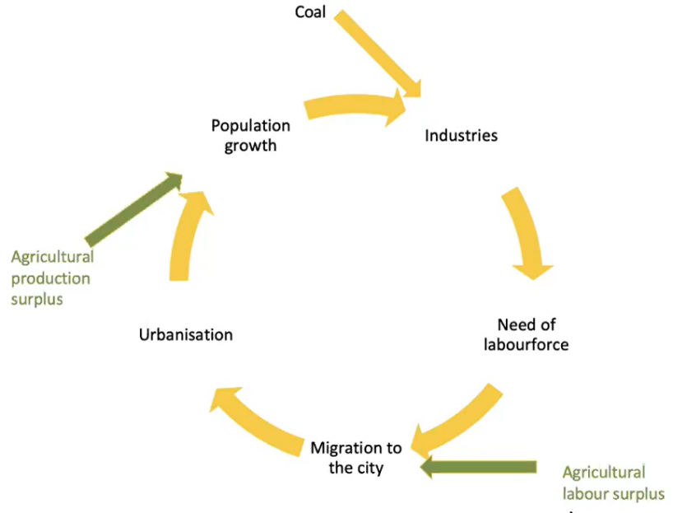

However, for the circle to complete and effective in economic development of the home country, the urban cities need continuous upgrade of infrastructure and governing institutions along with development of local markets market that integrated agricultural surplus into the economy.

Within the growing consumer society, Henry Ford through introduction of assembly line played a crucial role in shaping the industrial revolution through simplifying the processes and reduce error rates thereby reducing production costs and consequently lower sales costs. However, promoting higher wages among his workers meant higher purchasing power with consumers. This fueled by invention of steam engine significantly pushed the circle of growth above into hyper scale leading to exponential growth for England. The same was followed by other western countries who share similar attributes of having a matured infrastructure and highly literate population through continuous cycle of innovations that were protected via patent laws. To support this phase of hyper growth innovation in chemistry and modern medicine played a key role and improved life expectancy among working population especially within the cities. E.g. Life expectancy within urban England was 25-27 years or 15 years shorter than the country average owing to poor living and working conditions and overcrowding.

The working conditions among labor were improved by establishment and continuous maturity of work ethics that started with Marin Luther, who proposed hierarchal order, promoted work ethics and good behavior. Fueled by printing press and high literacy rates within Sweden, laws such as 1833 Legislative Law, 1842 Act on public schools, 1846 Statute of Defenselessness, 1847 Poor Law Ordinance and 1885 Vagrancy Law, to monitor social situation were established. These laws along with Philanthropy contributed towards elevating social situations and development of healthy people, leading to development of Peoples Movement. The organizations and labor unions setup during the Labor Movement were key to establishing modern day work ethics and practices that promoted high productivity and healthier living. E.g. In 1918 children auction is banned and 1919 universal suffrage and 8-hour working day were introduced. E.g. It was only through 1928 Labor Peace Conference and 1928 act on collective agreement that helped restore peace and stabilization within Sweden post 1920 crisis. Examples of major changes to the society within Swedish state happened within 1938 Saltsjobad Agreement and 1939 legislation that banned women to be dismissed post marriage. These laws were instrumental in introducing women as a permanent member of the labor workforce and improving the overall productivity through establishing means of conflict resolution among labor and company owners.

Owing to availability of highly literate workforce and established organizational structures, urban cities started to form center of innovation and productivity leading to high growth for the country. E.g. 1873 connecting water turbine to dynamo to produce electricity, use of Bessemer method in 1856 to produce cheap steal, innovation of propellers 1840s to revolutionalise waterways that made it possible to trade goods with lower yield per kilo and innovations such as printing press in late 1800s that made it possible for daily paper in every Swedish home by 1919 consequently fueling knowledge transfer and promoting social wellbeing among the population.

Concluding, while many factors played crucial role in development of western economies like Sweden, Ferguson’s six concepts competition, science, the rule of law, consumerism, modern medicine, and the work ethic, allowed them to leap ahead of the rest, opening global trade routes, exploiting newly discovered scientific laws, evolving a system of representative government, more than doubling life expectancy, unleashing the Industrial Revolution, and embracing a dynamic work ethic.

Sources:

1. Lecture Notes HIG750
2. [Civilization: The Six Ways the West Beat the Rest by Niall Ferguson](https://reviews.history.ac.uk/review/1225)